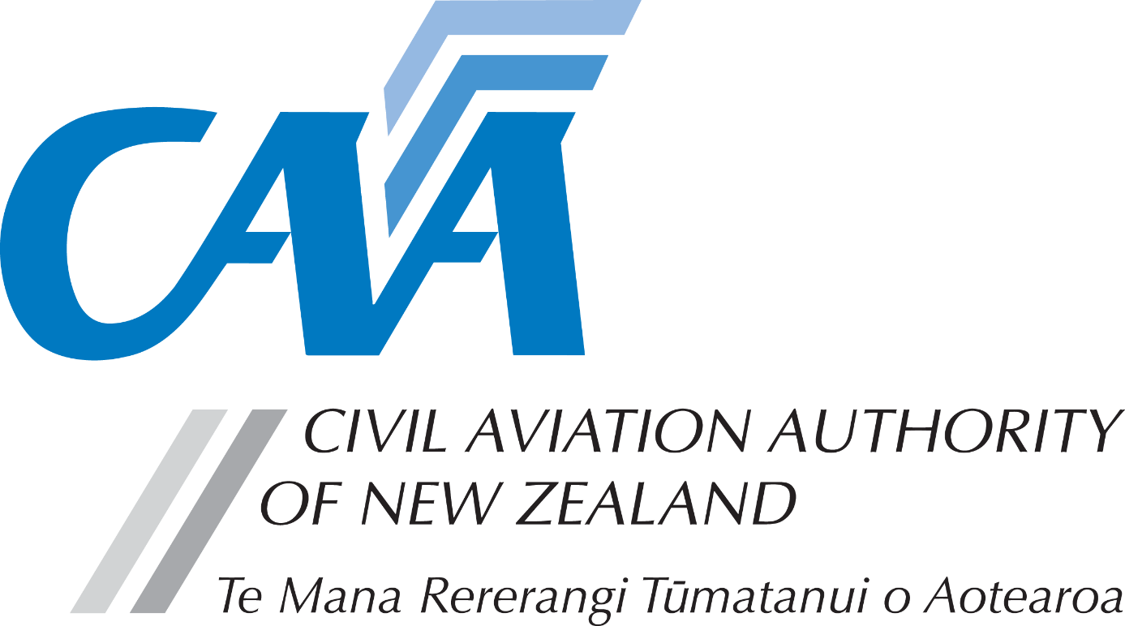
Aircraft Maintenance Engineer Licence – Rating

Notes to applicants:
- A completed Fit and Proper Person Questionnaire, form CAA 24FPP or CAA 24FPPDEC, is required with this application. Refer to the 24FPP form for guidance on the appropriate form to be used.
- Personal details
CAA participant number (if known) |  |  |  |  |  |  | Date of birth (dd/mm/yy)
Title (Mr/Mrs/Ms/Miss) |  |  |  | Last name
Given name(s)
Country of birth |  |  |  |  |  | Nationality
Address for service - Civil Aviation Act, s8, requires applicants to provide an address for service in New Zealand (i.e. a physical address) and to promptly notify the Director of any changes.

Phone |  |  |  | Mobile
Email
Postal address (if different from Address for Service)
Phone |  |  |  | Mobile
Email
- Rating application requirements
- Requirements for AME Licence issue are contained in Rule Part 66 and associated Part 66 Advisory Circulars (ACs). Read these at www.aviation.govt.nz under the heading Rules > Advisory Circulars.
- For details on rating requirements refer to AC 66-1 - Subpart C Aircraft Maintenance Engineer Ratings.
- For further information, please refer the CAA website, www.aviation.govt.nz click on Licensing & Certification on the home page, then Maintenance engineer licensing.
- Rating(s) applying for
Please give details of rating(s) applying for, in appropriate category(s). | Aeroplane |  | Electrical
 | Rotorcraft |  | Instrument
 | Powerplant |  | Radio
 | LTA Aircraft |  | Components

- Experience and course requirements
AC66-1 Experience requirements are summarised here  Refer to AC66-1 and CAA web site under the heading - Engineering / Type Rating Applications for more detailed explanation of rating requirements.  Experience must be submitted in a suitable PTR as required by AC66-1  Example PTRs are available on CAA web site under the heading Licensing & Certification – Maintenance engineer licensing | 1. Experience  A minimum of 6 months practical experience on the type or group of aircraft is required to be completed within the immediate three years before application to demonstrate familiarity and currency.  Documenting experience - Practical Training Record (PTR)  The format of any acceptable PTR should list the specific tasks completed, being countersigned by a supervising LAME, along with details of the dates and the specific aircraft or component.  As a guide, a typical PTR format is included in AC66-1 Appendix 4 and is electronically available on CAA web site under Maintenance engineer licensing.  Only experience specific to the rating(s) sought should be included or highlighted in some way in the PTR. The range and depth of the relevant experience should be readily evident from an assessment of the PTR.  Rating experience requirements  Practical experience should comprise a broad cross section of maintenance tasks at both Line and Base (Hangar) Maintenance Levels and should be across all relevant systems (appropriate ATA Chapters) for the category(s) being applied for.  Typically this should include:  - Completing all aspects of several line and base level routine inspections  - For transport category aircraft, a minimum of 3; and different C level type checks, and  - A cross section of the following representative tasks on the various aircraft systems:  - troubleshooting  - repair  - adjustments and rigging  - component and module changes  - functional/operational checks, and  - use of special tooling and test equipment.  Reference should be made to AC66-1 Appendix 3 which lists typical tasks by aircraft systems.
Include completed PTR with application | Group & Type Rating PTR  As a guide, typical acceptable practical experience for group ratings should include tasks listed in AC66-1 Subpart C and Appendix 3.  Transport Category Aircraft Type Rating PTR  This documentation is normally developed by the Part 145 Organisation as part of their company authorisation procedures. It should clearly detail or set out an acceptable cross section of specific tasks across the relevant systems (ATA Chapters) that must be completed prior to the issue of a company authorisation.  May also be developed by a Part 141 aviation training organisation for their type rating courses.
AC66-1 Course requirements summarised here  Include copies of relevant Course Certificates | 2. Course Certificates - Type ratings applications  A course must be:  - conducted by a Part 141 or a Part 145 organisation certificated with the appropriate E1 rating; or  - conducted by the manufacturer of the applicable aircraft or component; or  - approved by the competent authority of a foreign ICAO Contracting State.  Additionally, courses should:  - be developed/packaged to an industry recognised standard such as ATA Spec. 104 - Level III (Line and Base Level Maintenance), or an equivalent standard;  - cover all the relevant systems (ATA chapters) for the privilege of the category of licence;  - cover the series of aircraft or powerplants for which the rating provides privileges;  - cover a competency assessment element such as a technical oral.  Continuous or Significant Recent Experience  If more than 2 years has expired since course completion, the currency of type course may be satisfactory if can show continuous or significant recent practical experience on the type since completion of the course.
AC66-1 Tech Oral requirements summarised here  Include copies of Technical Oral certificates | 3. Technical Orals - Type Rating applications.  May be conducted by the applicant’s Part 145 Maintenance Organisation as part of their company authorisation procedures, or alternatively by a Part 141 Training School.  Note: As part of the requirements for a Part 145 company authorisation to be issued, the technical competence for the scope of the authorisation should be examined by an appropriate senior person within the company. [Refer Rule 145.60(e)(1)]  Where the course is conducted by a foreign course provider, that is approved by another ICAO contracting state, the technical oral may be conducted by the training provider using CAA guidelines.

- Application fees
- On a specific aircraft type, any mechanical ratings incur one fee and any avionics ratings incur another rating fee.
- Please pay online at https://sec.caa.govt.nz/onlinepayment and attach the receipt that will be emailed to you.
- For information relating to fees, refer to the Civil Aviation Charges Regulations.
Payment details
Total fees
Receipt number

- Declaration
The provision of false information or failure to disclose information relevant to the grant or holding of an aviation document constitutes an offence under Section 49 of the Civil Aviation Act 1990 and is subject, in the case of an individual, to imprisonment for a term not exceeding 12 months or to a fine not exceeding $10,000. | I declare that to the best of my knowledge and belief the statements made, and the information supplied in this application and the attachments are complete and correct.  Consent to Disclosure & Collection  I authorise the collection by the Director of Civil Aviation or his delegate (hereinafter referred to as "the Director") from, and the disclosure to the Director by, any person, organisation or government department of any details of my knowledge & compliance with transport safety regulatory requirements.  I authorise the Director to use, and disclose, the information obtained about me for any purpose under the Civil Aviation Act 1990, or other such purpose permitted by law.
 | Applicant’s Signature |  | Date
- Applicant’s checklist
Please ensure all documents are enclosed.  Applications which are incomplete or lacking any required documents will be returned. |  | Yes | N/A
 | - Fit and proper person questionnaire – either 24FPP or 24FPPDEC | ☐
 | - Copy of Practical Training Record | ☐ | ☐
 | - Copy of course and technical oral certificates | ☐ | ☐
 | - Payment receipt | ☐

Submit the completed application to either:
Email: lic.applications@caa.govt.nz
Post: Licensing and Standards, Civil Aviation Authority, PO Box 3555, Wellington 6140, New Zealand

